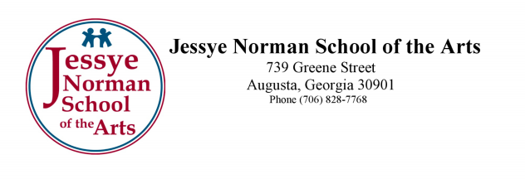

Contact: Gary Dennis, 706-814-0665 For Immediate Release
ExecDir@jessyenormanschool.org May 22, 2018

Jessye Norman School of the Arts to Create Original STEAM Play for Summer Camp, with Support of the Ford Foundation and Chestnut Family Foundation

On June 4th, the Jessye Norman School of the Arts’ first ever STEAM focused summer camp will begin, in partnership with Dr. Ashley Gess of Augusta University’s College of Education. The camp is made possible through the generous support of the Chestnut Family Foundation, created by Ben and Teresa Chestnut, and it will focus on the concept of STEAM: learning about STEM fields through the power of the Arts. At this camp, campers will have the chance to learn more about the scientific method, and they will explore STEM concepts through their choice of music, drama, dance, visual arts or photojournalism.

Additionally, the Ford Foundation has sponsored the creation of an original STEAM-focused musical, with music by composer Mark Swanson, and script by Sea Stachura. The play encourages women and minorities to select and stay in STEM related fields. The play is titled Hypatia of Harlem. Mark Swanson is a successful musician, composer and playwright with numerous credits. Sea Stachura is a graduate of the prestigious MFA program at Warren Wilson College, and she has been a contributing journalist for NPR and an instructor at Augusta University.

“The explosion of science and technology has reached such a level that no area of study can ignore its importance,” says JNSA’s executive director, Gary Dennis. “This is a tremendous opportunity for our school and our community to help demonstrate the idea that art and technology inspire and advance achievement together.”

The Summer Camp will have two sessions, one in June and the other in July. The first performance of the new play will take place June 22nd, and the second performance will take place July 27th. Outreach and research outcomes will follow in 2019.

# # #

